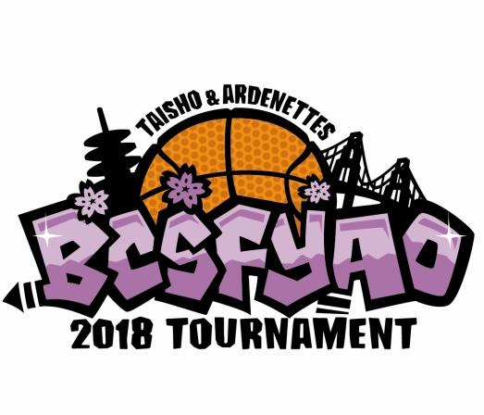
38th ANNUAL BCSF YAO
INVITATIONAL BASKETBALL TOURNAMENT
April 7 and 8, 2018

Waiver/Release Form

Team Name: Division:

We, the undersigned, release the San Francisco Unified School District, the South San Francisco Unified School District, the San Mateo County Unified School District, the Jefferson Union High School District, Pacifica School District, UCSF Mission Bay, Schools of the Sacred Heart San Francisco, JCCCNC, and Mercy High School and any of its officers, agents and employees, the Buddhist Church of San Francisco, the BCSF YAO (including its Tournament Committee, team coaches, and officials) from all liability for any injury or loss sustained by the player while playing, practicing, traveling and participating in the BCSF YAO Basketball Tournament and any related activities.

We understand that medical insurance is our own responsibility. The signing of the waiver/release form shall be considered as a waiver of any claim for any such injury or loss.

Print Name of Player | Signature of Player | Parent/Guardian Signature | Date
Print Name of Player | Signature of Player | Parent/Guardian Signature | Date

