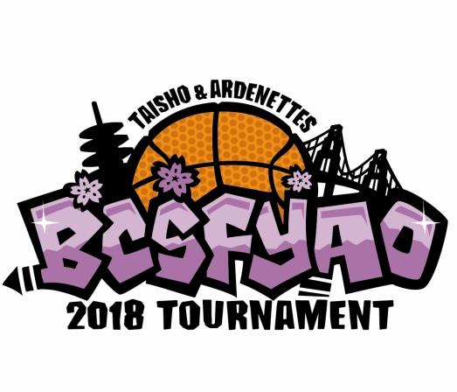
Concussion Understanding

On January 1, 2012, AB 25, a new law on youth sports concussions took effect in California.
The law was signed by Governor Brown on October 4, 2011.

The law has several provisions which impacts youth sports:

- Education: In order to participate in athletics, student and a parent or guardian must sign and return to the student’s school/program each year a form acknowledging receipt and review of a concussion and traumatic brain injury information sheet

- Suspected concussion: Athletes suspected of having sustained a concussion must be immediately removed from play for the remainder of the day.

- Written medical clearance: Athletes who have been removed may not return to play until evaluated and received written clearance from a licensed health care provider trained in the management of concussion acting within the scope of his or her practice.

Please have your players and parents or guardians sign the form below acknowledging that they have received and read the information concerning concussions and understand that BCSF YAO will be implementing this law for our tournament. Please return this completed form to your division coordinator.
---------------------------------------------------------------------------
We have received and read the provisions under AB 25 and the Concussion Information Sheet* provided by BCSF YAO. We understand the BCSF YAO, that if there is a question of a concussion, AB 25 will be implemented.

Team: ________________________________________ Grade: ________ Division: ___________

 | Player’s Signature | Parent’s or Guardian’s Signature
1
2
3
4
5
6
7
8
9
10
11
12
*For further information on concussions, please consult your physician.

CONCUSSION INFORMATION SHEET

WHAT IS A CONCUSSION?

A concussion is a brain injury. Concussions are caused by a bump or blow to the head. Even a "ding", "getting your bell rung”,
or what seems to be a mild bump or blow to the head can be serious. You can't see a concussion. Signs and symptoms of
concussion can show up right after the injury or may not appear or be noticed until days or weeks after the injury. If your child
reports any symptoms of concussion, or if you notice the symptoms yourself, seek medical attention right away.

WHAT ARE THE SIGNS AND SYMPTOMS OF A CONCUSSION?

Signs Observed by Parents or Guardians
If your child has experienced a hump or blow to
the head during a game or practice, look for any Symptoms Reported by Athlete
of the following signs and symptoms of a Headache or "pressure" in head
concussion: Nausea or vomiting
• Appears dazed or stunned Balance problems or dizziness
• Is confused about assignment or position Double or blurry vision
• Forgets an instruction Sensitivity to light
• Is unsure of game, score, or opponent Sensitivity to noise
• Moves clumsily Feeling sluggish, hazy, foggy, or groggy
• Answers questions slowly Concentration or memory problems
• Loses consciousness (even briefly) Confusion
• Shows behavior or personality changes Does not "feel right"
• Can't recall events prior to or after hit or fall

HOW CAN YOU HELP YOUR CHILD PREVENT A CONCUSSION?

• Every sport is different, but there are steps your children can take to protect themselves from concussion.
• Ensure that they follow their coach's rules for safety and the rules of the sport.
• Encourage them to practice good sportsmanship at all times.
• Make sure they wear the right protective equipment for their activity (such as helmets, padding, shin guards, and eye and
mouth guards). Protective equipment should fit properly, be well maintained, and be worn consistently and correctly. Learn
the signs and symptoms of a concussion.

WHAT SHOULD YOU DO IF YOU THINK YOUR CHILD HAS A CONCUSSION?

• Seek medical attention right away. A health care professional will be able to decide how serious the concussion is and
when it is safe for your child to return to sports.
• Keep your child out of play. Concussions take time to heal. Don't let your child return to play until a heath care
professional says it's OK. Children who return to play too soon-while the brain is still healing-risk a greater chance of having
a second concussion. Second or later concussions can be very serious. They can cause permanent damage, affecting your
child for a lifetime.
• Tell your child's coach about any recent concussion. Coaches should know if your child had a recent concussion in
ANY sport. Your child's coach may not know about a concussion your child received in another sport or activity unless you
tell the coach.

WHAT IS THE PROCEDURE FOR A SUSPECTED CONCUSSION?

• Any athlete who is suspected of sustaining a concussion or head injury in a practice or game shall be removed from the
activity at that time and for the remainder of the day.
• Any athlete who has been removed may not return to play until the athlete is evaluated by a licensed health care provider
trained in the evaluation and management of concussion and has received a written clearance to return to play from the
health care provider.

LET YOUR CHILD'S COACH KNOW RIGHT AWAY IF YOU SUSPECT YOUR CHILD HAS A CONCUSSION!
Adapted from the CDC. For more information you can go to: http://www.cdc.gov/ConcussionlnYouthSports

